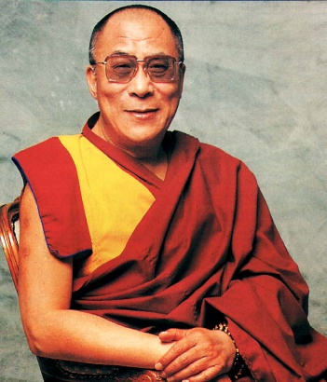
LARCHES HIGH SCHOOL
OPTIONS BOOKLET
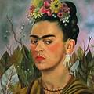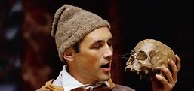
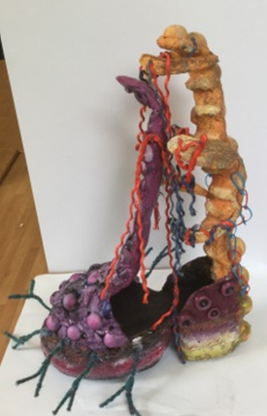
GCSE Art and Design
We currently are following the AQA Art and Design syllabus.

According to your interests and ability you have the choice of the following specialisms or a broad course that covers a selection of areas.

- Unendorsed - you will follow a broad area of Art and Design
- Fine Art – If you have a talent and an interest in Painting and Drawing then this will suit you.
- Textiles/Fashion - you have the opportunity to produce textiles artwork and work on fashion design projects.
- 3D - if you like making things you could be working in any material such as ceramics, card, fabrics and mixed media.
- Photography - this is a new area here at Larches High and you will cover the basics of digital photography to produce creative images and photographs. You will need a sound understanding of ICT to complete this endorsement as it is an important part of the course.
- Graphics - this is suitable if you are more interested in producing a more commercial style of artwork using Graphic images and ICT you will produce work such as posters, CD covers and advertising campaigns.

Coursework All work completed in class will go towards your GCSE and accounts for 60% of the total GCSE mark.
The syllabus follows a logical course of research, planning and developing through experimentation to produce a final piece showing your ideas. Work must also be annotated to explain your thoughts and ideas clearly.
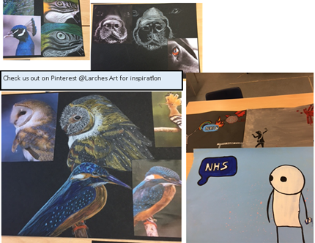
Exam
You will also be required to take a timed test which takes the form of a mini project which will account for the other 40% of your grade. You will be guided by experienced staff and as long as you can complete all the pieces of work set for you, we expect every Larches pupil to achieve a good grade.

Three-Dimensional Design & Technology

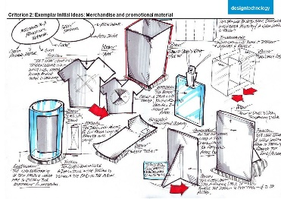

Is Three-Dimensional Design for you?
- Are you creative?
- Are you imaginative?
- Do you enjoy problem solving?
- Are you motivated and can you commit long term to ongoing projects?
- Can you take a paper based idea and develop it through to a finished 3-Dimensional product.
- Do you have a broad range of skills both communications based (drawing, annotating, analysing & evaluating) and practical based.

The school has recently developed a new Design and Technology department where pupils have the opportunity to complete a GCSE qualification (AQA).
GCSE Three-Dimensional Design & Technology (DT)
Students will study the new specification which sets out the knowledge, understanding and skills required to undertake the design processes of exploring, creating and evaluating.
Students will cover a range of core and specialist technical principles of Design & Technology and also develop the ability to design and make products with creativity and originality, using a range of materials and techniques.
Appreciation and investigation into the work of designers, artists, art movements and other relevant creative areas will also be studied during the course.
Students are required to develop their practical knowledge of timber, paper and boards, metals, polymers, textiles and electronic and mechanical systems. The use of new technologies is also encouraged, including using 3D design & modeling software and laser cutting.
AQA Exam Assessment 50% GCSE (100 marks) Non - Exam Assessment 50% GCSE (100 marks)
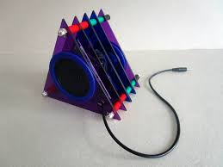
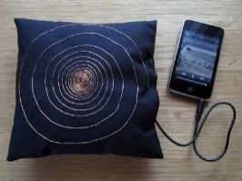
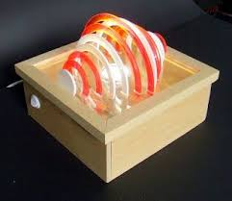
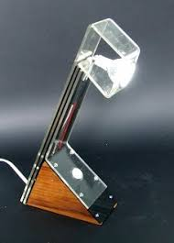
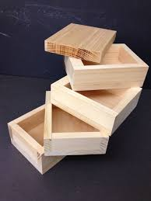
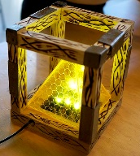

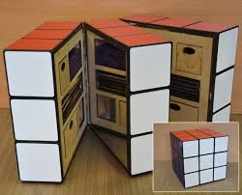

Hospitality and Catering
In this subject we will be learning all aspects of the following:-
Health, safety and hygiene
Food presentation, cooking and presentation
Nutrition
Menu planning
Portion control and costing

The course will also cover aspects of:-
The industry – food and drink
Job roles, employment and training
Specialist equipment (for food preparation, cooking and serving)
Communication and record keeping
Environmental considerations

This BTEC qualification will cover both practical and theory lessons and is coursework based. With motivation, attendance and commitment to the subject you will have no problem achieving a good grade.
If you are a bit of a foodie, come and give it a try!!!

Physical Education

Physical Education at Larches is designed to engage young people both KS3 and KS4 in physical activity to support both physical and mental health and ensure a long term interest participating in sport. We deliver an engaging, fun and exciting learning environment where the teaching is both challenging, progressive and supportive. Pupils develop key physical attributes, emotional resilience and a number of key social skills by working cooperatively and confidentially in teams.
Core Physical Education
All pupils take part in Core PE as part of their school curriculum, from Year 7 through to Year 11. Pupils work on sports specific units lasting no more than 6 lessons at a time. Teachers routinely model tasks and use expert questioning techniques to develop pupils understanding. The specific aim is to improve the quality and range of skills across a variety of activities in order to support the sports available.
How will I get a GCSE in Physical Education? (Edexcel Full Course)
Pupils can undertake the two year GCSE course starting in Year 10.
Written Examination – This will consist of a mixture of multiple-choice questions, short-answer questions and longer-answer questions on the following topics, fitness and body systems and health and performance. This will make up 60% of the qualification.
Practical activities – You will get the chance to learn and develop your skills in a wide variety of sports, building on the core techniques learnt during core PE lessons. The course requires pupils to choose three sports to be practically assessed in. Pupils will choose the three sports in which they will score the highest marks.
If Pupils participate in sport outside of school, then other arrangements can be made for pupils to be assessed at their club. The assessment will consists of students completing three physical activities from a set list. One must be a team activity; one must be an individual activity and the other is your choice. This will make up 30% of the qualification.
Coursework – Pupils will be required to plan and follow a six-week personal exercise programme (PEP) designed by themselves before completing their individual programme. This plan will show progression and work towards an end target or goal. This will make up 10% of the qualification.
GCSE History
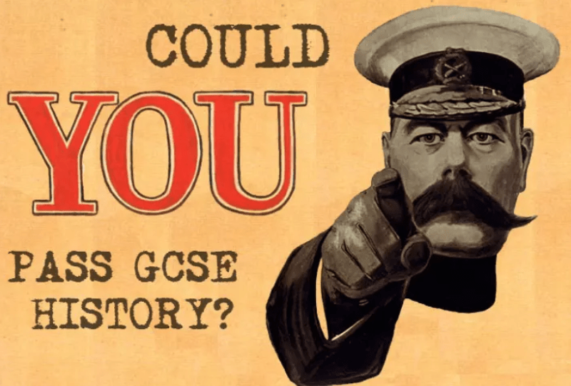
Throughout KS4, students gain a detailed knowledge and understanding of the past and develop the skills needed to investigate it. Students follow the EDEXCEL course. The course investigates a range of different historical periods such as Medicine in Britain, Early Elizabethan England, The Cold War and Weimar and Nazi Germany.
Some of the topics from KS3 reappear in KS4 but they study them in more depth. An example would be WWII and Nazi Germany. Good written communication is at the core of GCSE History and candidates will develop their ability to produce both well written and well-structured essays.
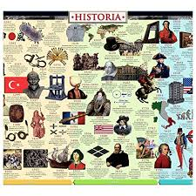
Topics Covered in Year 10:
- Medicine in Britain from 1700–Present Day
- Early Elizabethan England
- The American West 1835-1895

Topics Covered in Year 11:
- Conflicts and conquest, c1876–c1895
- The Weimar Republic 1918-29
- Nazi Germany
GCSE R.E.

WJEC Eduqas GCSE Religious Studies provides opportunities for learners to
understand more about the world, the religious challenges it faces and their place
within it. Following this GCSE course will deepen understanding of religions and their
effect on society. It will develop learners' competence in a wide range of skills and
approaches and enable young people to become religiously informed and thoughtful,
engaged citizens.

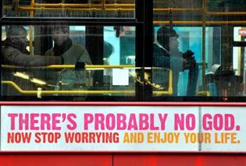

As part of the course students will learn about the following themes:-

- Issues of Relationships
- Issues of Life and Death
- Issues of Good and Evil
- Issues of Human Rights

Learners will also know and understand the fact that the religious traditions of Great Britain are, in the main, Christian, but also diverse and include the following religious and non-religious traditions: Christianity, Buddhism, Hinduism, Islam, Judaism, Sikhism, Humanism
and Atheism.

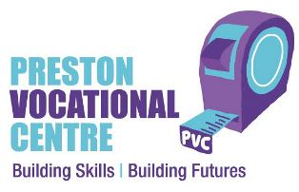
Would you benefit from learning practical construction skills away from school?
If so our 14-16 programme might be the right option for you.
As well as working towards a vocational qualification in construction, you’ll also gain experience within a professional pre-college environment which is very different to school.

What do we do?
Preston Vocational Centre has a well-established and good reputation for providing vocational training in construction, with high quality pastoral support, to young people in Lancashire since 2009.

We provide opportunities that develop character traits and behaviours to support young people with gaining skills and confidence for building a positive future. Our Centre ethos promotes a secure, supportive and positive environment which gives everyone a sense of feeling respected and valued.

What will the student study as part of this qualification?
This practical BTEC course is an ideal basis for developing construction skills. It provides an engaging and relevant introduction to the world of construction, preparing young people for a range of trades within the construction industry that includes:
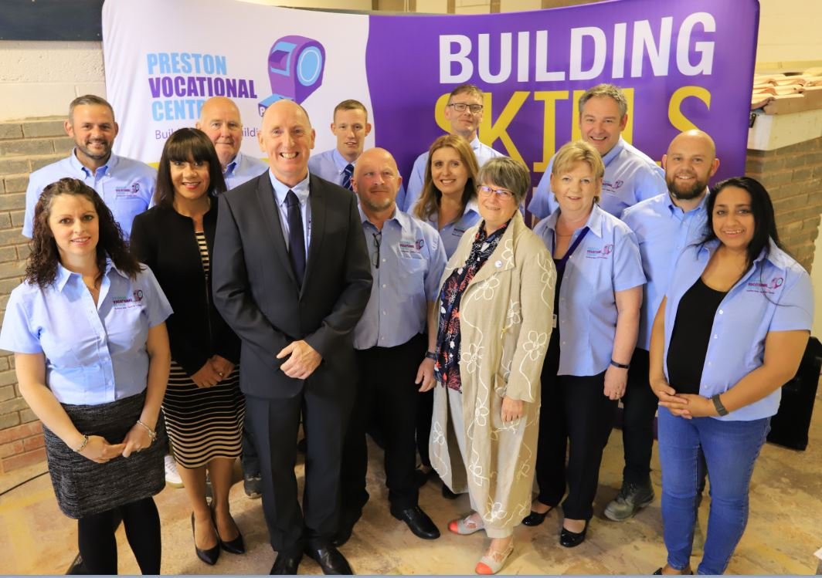
- Bricklaying
- Plastering
- Joinery and Carpentry
- Painting
- Plumbing
- Manual Handling
- Health and Safety in Construction

What qualification do we offer?
BTEC Level 1 in Construction

Moving on…
As part of our programme, we will support young people with applying for an apprenticeship, further education, training, or employment. Although we cannot guarantee a permanent position at the end of the programme, we provide young people with transferable skills, a qualification and valuable experience that will benefit their future career. Achievement of a level 1 qualification will give young people the opportunity to apply directly on to level 2 vocational courses or apprenticeships with their chosen provider.

Hair & Beauty
These qualifications have been designed to help learners understand aspects of the hair and beauty industry and to cover some of the knowledge and practical skills required to work successfully within it.
Hair & Beauty will be taught on site at Larches High school on Fridays. Qualified instructors will be visiting the school to deliver the course.
Pupils can gain the following accreditations :-
BTEC Level1 Award/Certificate/Diploma in Introductory Hair and Beauty

Level 1 Award in Health and Social Care
Who is this Level 1/2 Award in Health and Social Care for?
This course is designed for learners aged 14‒16 who have an interest in health and social care and wish to develop skills and learn the theory that can prepare them for further study and employment within this sector. It will particularly appeal to learners who are looking for a course that is practical in nature.
Description of the course:
The course content provides learners with a stimulating and engaging introduction to the health and social care sector. It covers a range of skills and in-depth knowledge in different aspects of growth and development. Students will develop essential knowledge in health and social care services and demonstrate some care values throughout the course to enable them to care for others in need.
What will learners study?
Learners will complete three mandatory units (one externally assessed and two internally assessed) spread across 120 guided learning hours. This is a two year course.
Unit 1: Improving the wellbeing of an individual
Learners will choose a client and carry out a range of testing techniques to measure and evaluate their health and then produce, implement and review a plan that will aim to make lifestyle changes that could improve their health. They will then review and evaluate the impact this plan has had on their chosen client.
Unit 2: Promoting healthy living
In this unit learners will research and evaluate existing health promotion campaigns and then plan and deliver their own health promotion campaign. This involves an element of creativity that learners will enjoy, particularly as they will have the freedom to choose the type of materials they produce, from posters or wall displays in schools to promotional videos or radio scripts. At the end, learners will review and evaluate the success of their campaign.
Unit 3: Development through the life stages
Learners will study the fundamentals of health and social care and acquire the underpinning knowledge required to carry out the two practical units. This knowledge will be relevant when considering future career choices and further study options. This unit covers:
• The stages and patterns of human growth and development
• Expected development at each life stage
• Life events
• Sources of support/services for life events
• Roles of professionals from the sectors who are involved in supporting life events
• Definitions of health and wellbeing

